DSA Lab04

23K2001

M.Muzammil Siddiqui

BCS-3J

Q1:

//23K2001 - Muzammil

#include<iostream>

using namespace std;

void sortByRange(int *arr,int n,int x,int y){

    if(x>n || y>n || x<0 || y<0){

        cout<<"Exceeded bounds!"<<endl;

        return;

    }

    if(x==y)

    return;

    if(x<y){

        for(int i=x;i<y;i++){

            int min_index = i;

            for(int j=i+1;j<y+1;j++){

                if(arr[j]<arr[min_index])

                    min_index = j;

            }

            int temp = arr[i];

            arr[i] = arr[min_index];

            arr[min_index] = temp;

        }

    }

    else{

        for(int i=x;i<n-1;i++){

            int min_index = i;

            for(int j=i+1;j<n;j++)

                if(arr[j] < arr[min_index])

                    min_index = j;

            int temp = arr[i];

            arr[i] = arr[min_index];

            arr[min_index] = temp;

        }

        for(int i=0;i<y;i++){

            int min_index = i;

            for (int j=i+1;j<y+1;j++)

                if (arr[j] < arr[min_index])

                    min_index = j;

            int temp = arr[i];

            arr[i] = arr[min_index];

            arr[min_index] = temp;

        }

    }

}

int main(){

    int *m = nullptr;

    int n;

    cout<<"How many elements: ";

    cin>>n;

    m = new int[n];

    cout<<"Enter "<<n<<" elements:"<<endl;

    for(int i=0;i<n;i++)

    cin>>m[i];

    int a,b;

    cout<<endl<<"Enter range [a,b] to sort: ";

    cin>>a>>b;

    sortByRange(m,n,a,b);

    cout<<"After sorting in range:"<<endl;

    for(int i=0;i<n;i++)

    cout<<m[i]<<"\t";

    delete[] m;

    return 0;

}

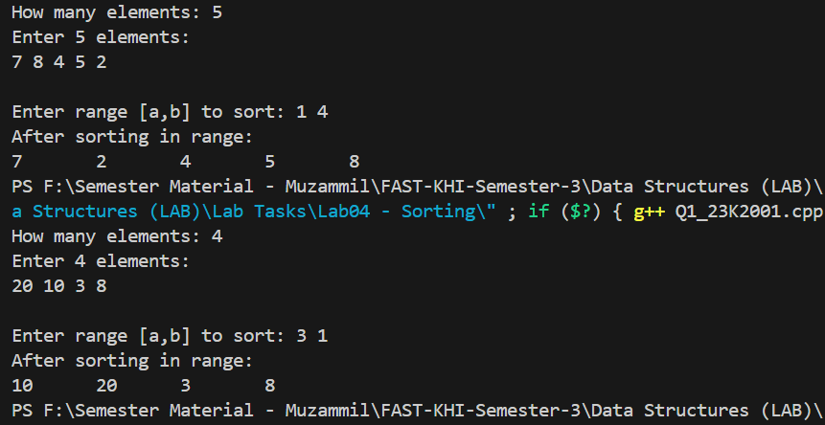

Q2:

//23K2001 - Muzammil

#include<iostream>

using namespace std;

void largestToMiddle(int *arr,int n){

    for(int i=1;i<n;i++){

        int key = arr[i];

        int j = i-1;

        while(j>=0 && arr[j]>key){

            arr[j+1] = arr[j];

            j--;

        }

        arr[j+1] = key;

    }

    int mid = n/2;

    int temp = arr[n-1];

    int j=n-1;

    while(j>mid){

        arr[j] = arr[j - 1];

        j--;

    }

    arr[mid] = temp;

}

int main(){

    int *m = nullptr;

    int n;

    cout<<"How many elements: ";

    cin>>n;

    m = new int[n];

    cout<<"Enter "<<n<<" elements:"<<endl;

    for(int i=0;i<n;i++)

    cin>>m[i];

    largestToMiddle(m,n);

    cout<<endl<<"After sorting, & largest to middle:"<<endl;

    for(int i=0;i<n;i++)

    cout<<m[i]<<"\t";

    delete[] m;

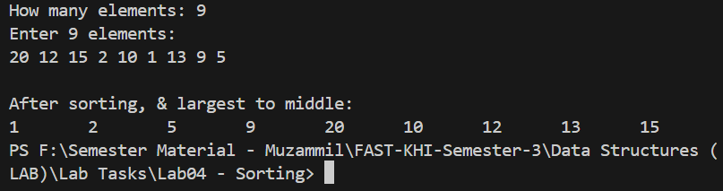    return 0;

}

Q3:

//23K2001 - Muzammil

#include<iostream>

using namespace std;

void sortString(string *s,int n){

    for(int i=0;i<n-1;i++){

        for(int j=0;j<n-1;j++){

            if(s[j] > s[j+1]){

                string temp = s[j];

                s[j] = s[j+1];

                s[j+1] = temp;

            }

        }

    }

}

int main(){

    string *m = nullptr;

    int n;

    cout<<"How many elements: ";

    cin>>n;

    m = new string[n];

    cout<<"Enter "<<n<<" words:"<<endl;

    for(int i=0;i<n;i++)

    cin>>m[i];

    sortString(m,n);

    cout<<endl<<"After sorting:"<<endl;

    for(int i=0;i<n;i++)

    cout<<m[i]<<"\t";

    delete[] m;

    return 0;

}

Q4:

//23K2001 - Muzammil

#include<iostream>

using namespace std;

template<class T>

bool haveDuplicates(T *arr,int n){

    for(int i=0;i<n;i++){

        for(int j=i+1;j<n;j++){

            if(arr[i]==arr[j])

            return true;

        }

    }

    return false;

}

int main(){

    int *m = nullptr;

    int n;

    cout<<"How many elements: ";

    cin>>n;

    m = new int[n];

    cout<<"Enter "<<n<<" elements:"<<endl;

    for(int i=0;i<n;i++)

    cin>>m[i];

    cout<<endl<<"Checking for duplicates:"<<endl;

    if(haveDuplicates(m,n)==true)

    cout<<endl<<"inputted array has duplicates."<<endl;

    else

    cout<<endl<<"no duplicates."<<endl;

    for(int i=0;i<n;i++)

        cout<<m[i]<<"\t";

    delete[] m;

    return 0;

}

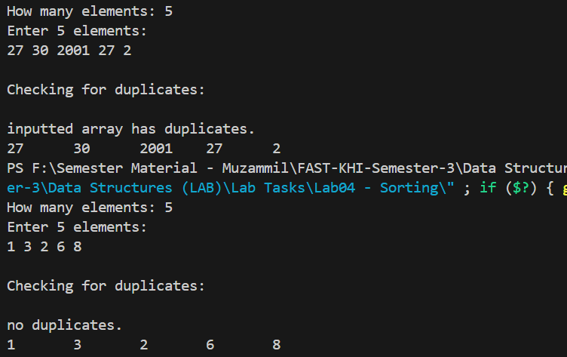

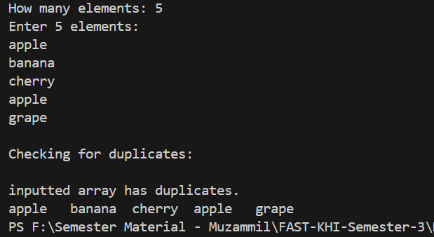

Q5:

//23K2001 - Muzammil

#include<iostream>

using namespace std;

void sortYear(int *arr,int n){

    for(int i=0;i<n-1;i++){

        for(int j=0;j<n-1;j++){

            if(arr[j] > arr[j+1]){

                int temp = arr[j];

                arr[j] = arr[j+1];

                arr[j+1] = temp;

            }

        }

    }

}

int main(){

    int *m = nullptr;

    int n;

    cout<<"How many children: ";

    cin>>n;

    m = new int[n];

    cout<<"Enter "<<n<<" birth years:"<<endl;

    for(int i=0;i<n;i++)

    cin>>m[i];

    sortYear(m,n);

    cout<<endl<<"After sorting:"<<endl;

    for(int i=0;i<n;i++)

        cout<<m[i]<<"\t";

    delete[] m;

    return 0;

}

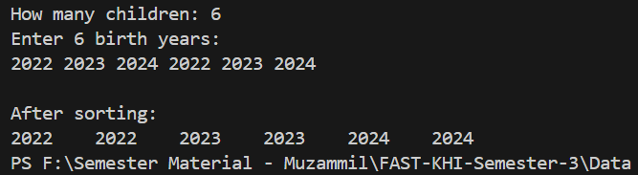

Q6:

//23K2001 - Muzammil

#include<iostream>

using namespace std;

int binSearch(int *arr,int n,int key){

    int left = 0;

    int right = n-1;

    while(left <= right) {

        int mid = left + (right - left)/2;

        if (arr[mid] == key)

            return mid;

        else if (arr[mid] < key)

            left = mid + 1;

        else

            right = mid - 1;

    }

    return -1;

}

void sortArr(int *arr,int n){

    for(int i=0;i<n-1;i++){

        for(int j=0;j<n-1;j++){

            if(arr[j] > arr[j+1]){

                int temp = arr[j];

                arr[j] = arr[j+1];

                arr[j+1] = temp;

            }

        }

    }

}

int main(){

    int *m = nullptr;

    int n;

    cout<<"How many elements: ";

    cin>>n;

    m = new int[n];

    cout<<"Enter "<<n<<" elements:"<<endl;

    for(int i=0;i<n;i++)

    cin>>m[i];

    sortArr(m,n);

    cout<<endl;

    for(int i=0;i<n;i++)

    cout<<m[i]<<"\t";

    int x;

    cout<<endl<<"Enter value to search for: ";

    cin>>x;

    int res = binSearch(m,n,x);

    if(res!=-1)

    cout<<"Value present at index#"<<res<<endl;

    else

    cout<<"Value couldn't be found."<<endl;

    delete[] m;

    return 0;

}

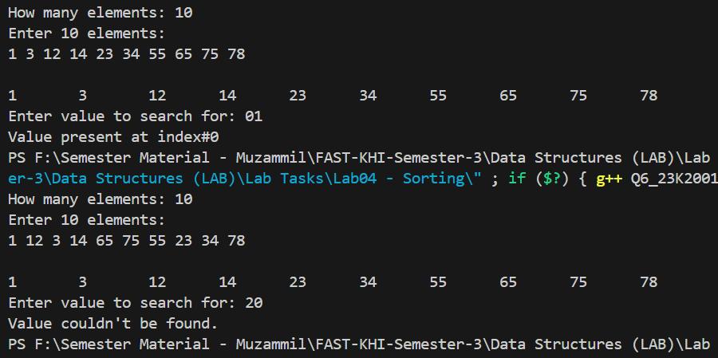



Q7:

//23K2001 - Muzammil

#include<iostream>

using namespace std;

int binSearch(string *arr,int n,string key,int &c){

    int left = 0;

    int right = n-1;

    while(left <= right) {

        int mid = left + (right - left)/2;

        c++;

        if (arr[mid] == key)

            return mid;

        else if (arr[mid] < key)

            left = mid + 1;

        else

            right = mid - 1;

    }

    return -1;

}

int linearSearch(string *arr,int n,string key,int &c){

    for(int i=0;i<n;i++){

        c++;

        if(arr[i]==key)

        return i;

    }

    return -1;

}

int main(){

    string *m = nullptr;

    int n;

    cout<<"How many elements: ";

    cin>>n;

    m = new string[n];

    cout<<"Enter "<<n<<" elements:"<<endl;

    for(int i=0;i<n;i++)

    cin>>m[i];

    string x;

    cout<<endl<<"Enter value to search for: ";

    cin>>x;

    cout<<endl<<"By binary search:"<<endl;

    int c1 = 0;

    int res1 = binSearch(m,n,x,c1);

    if(res1!=-1)

        cout<<"Value present at index#"<<res1<<endl;

    else

        cout<<"Value couldn't be found."<<endl;

    cout<<"Steps taken: "<<c1<<endl;

    cout<<endl<<"By linear search:"<<endl;

    int c2 = 0;

    int res2 = linearSearch(m,n,x,c2);

    if(res2!=-1)

        cout<<"Value present at index#"<<res2<<endl;

    else

        cout<<"Value couldn't be found."<<endl;

    cout<<"Steps taken: "<<c2<<endl;

    delete[] m;

    return 0;

}

